Proposal for project 1

Project Title- Learn the Lyrics

Team Members – Julius Conaway, Chris Guzman, and Jowensky Neard.

Project Description – Creating a database for clients to search lyrics and videos of a chosen artist.

Sketch of Final Product –

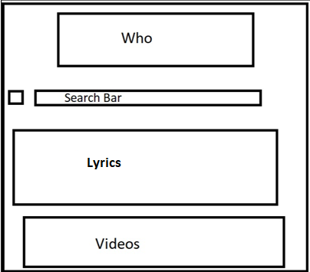

API’s to be Used – We will be using both YouTube and Musixmatch for our project.

Rough Breakdown of Tasks – Julius Conaway will take point on the front end work and the overall display of page. While Jowensky Neard will take the point of dynamically using the API for. MusixMatch to show lyrics with searches. Finally Chris Guzman will take the lead on dynamically getting the You Tube API’s to populate our videos along with the searches.